MS SQL SERVER
Standard Operating Procedures
(SOP)

Performing Backup in SQL Server

Submitted to



By



CIS, Wipro Limited

Document Details

Project Name | Innogy SE
Account | CIS
IT Component/Application Title | Performing Backup In SQL Server
Current Version | 1.5
List of Contributors | Pradipkumar Kansara, Kiran Bhalekar, Ayushi Gautam, Sivakumar Goud, Ayushi Srivastava
Customer Contact Information

Version History
(All revisions made to this document must be listed in chronological order. All revisions must be approved. Review and Approval can be done by an internal source or by the customer)
Version | Date of Revision | Description | Author | Reviewed By | Approved By
1.0 | 29-08-2015 | Initial Draft | Ayushi Gautam | Pradipkumar Kansara | Mahesh Keshatwar
1.1 | 04-09-2015 | Document Completed | Ayushi Gautam | Pradipkumar Kansara | Mahesh Keshatwar
1.2 | 21-08-2016 | Updated document to standard format | Kiran Bhalekar | Pradipkumar Kansara | Mahesh Keshatwar
1.3 | 17-05-2017 | Wipro and Innogy Logo changed | Ayushi Gautam | Pradipkumar Kansara | Mahesh Keshatwar
1.4 | 14-09-2017 | Updated document to Wipro Standard format with header and footer | Kiran Bhalekar | Pradipkumar Kansara | Santosh Badiger
1.5 | 19-12-2018 | Updated the content | Ayushi Srivastava | Pradipkumar Kansara | Santosh Badiger

Document Distribution List
S.No | Name and Company | Purpose
1 | RWEIT-SQLDBA | This document is about SQL Performing in SQL server
2

TABLE OF CONTENT
1. Purpose 1
2. Scope 1
3. Process Flow For Backup Monitoring 1
4. Backup 1
4.1 Open The Backup Database Window 2
4.2 Add The Disk Path To Take Backup And Take Backup 2
4. Reference 6

1. Purpose
This document is prepared for the management and troubleshooting of SQL Server Database Administration Services at Customer.

2. Scope
This document is prepared for GNDC Wipro sustenance team and provides the concepts, management and troubleshooting aspects of Backup for the administration of the SQL Server database at Customer.

3. Process Flow For Backup Monitoring
The process flow for backup monitoring is as below:

Note: The above flow is a draft. It is required to be modified as per the customer needs.

4. Backup
Steps to perform backup of database is as follows:

4.1 Open the Backup database Window
Right Click on <database_name> > Tasks > Backup…>
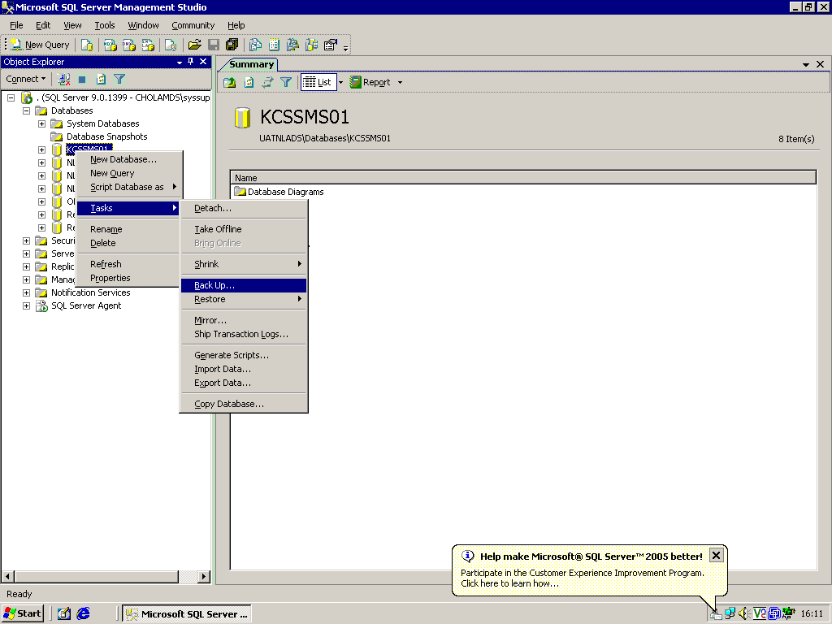

The Backup Database will be viewed as below:

4.2 Add the disk path to take backup and take backup
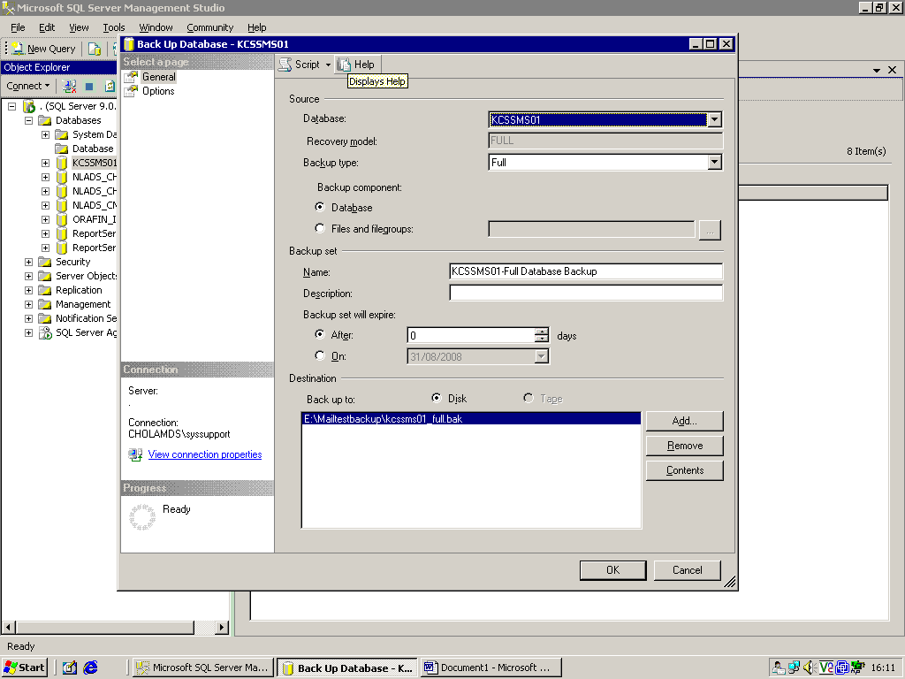
Click on Add.. to add the disk path.
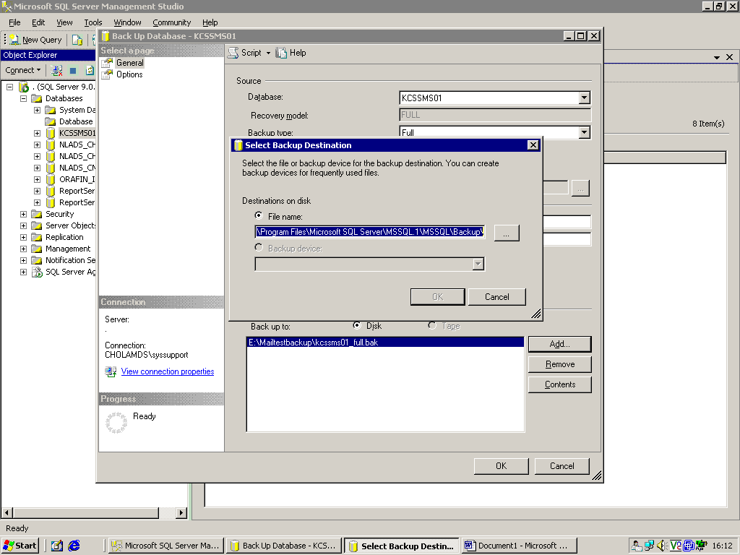
Click … to select the location where backup is to be taken.

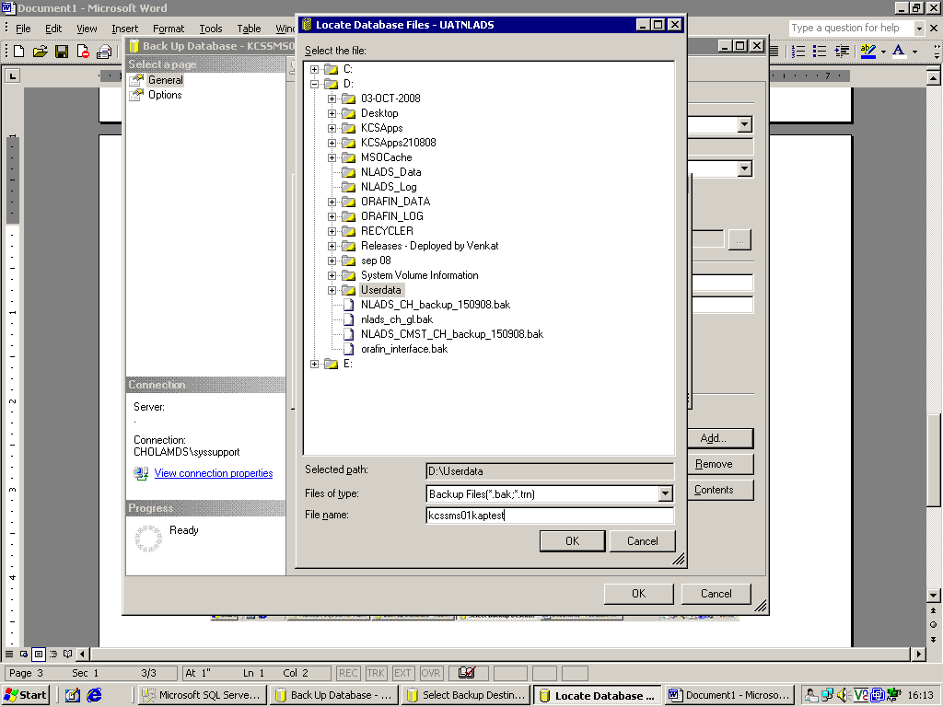
In Locate Database Files window, select the database for which backup has to be taken.
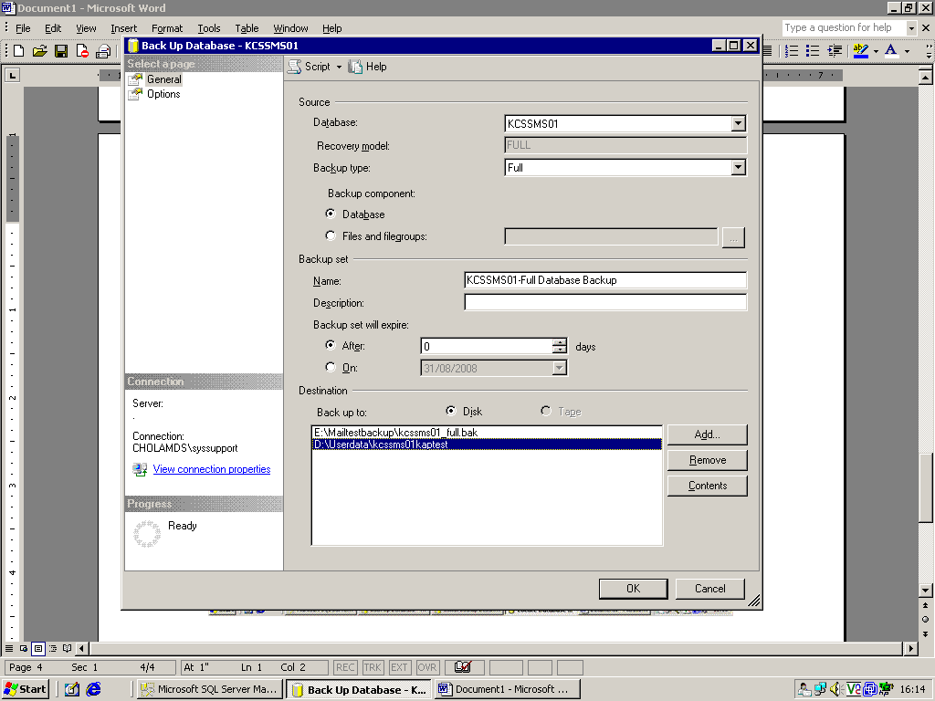
Click ok

Once Backup is completed, the following message will be displayed
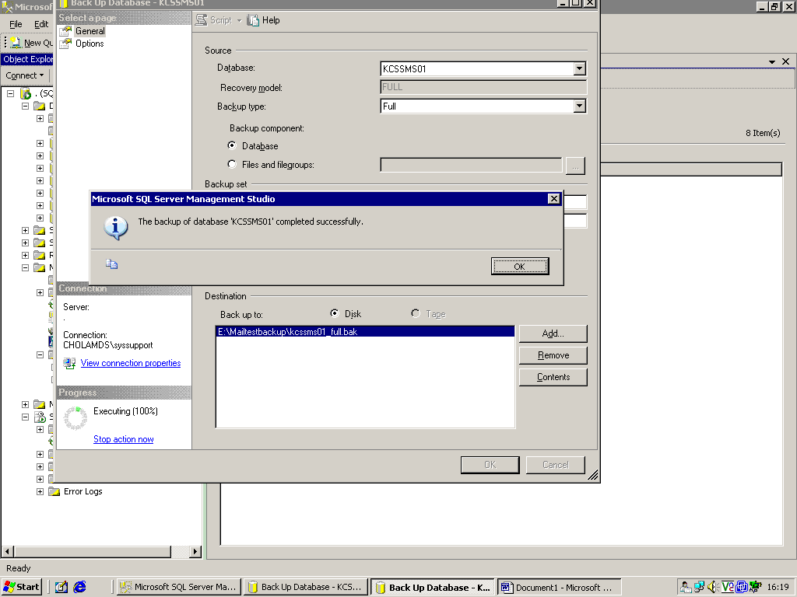

4. Reference
http://msdn.microsoft.com/en-us/library/ms187510.aspx

